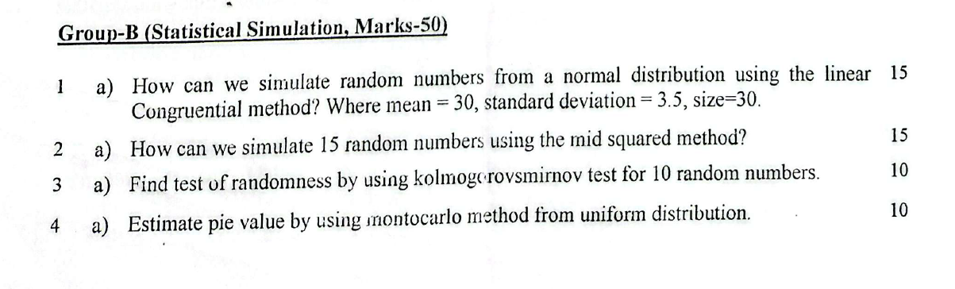
1.(a)
a | 1664525
c | 1013904223
m | 4294967296
seed | 12345

X_{n+1}=aX_{n}+c
Step:1: seed =12345
step 2: Xi=MOD(1664525*X₀(SEED) +103904223,2^32)
Ui=X_{i}/2^32 (note: 2^32= 4294967296)
R_{i}= NORM.INV(U₁,mean,std.dev)
OUTPUT:
Xi |  | Ui |  | Ri
12345
87628868 |  | 0.020403 |  | 22.84074
71072467 |  | 0.016548 |  | 22.54178
2332836374 |  | 0.543156 |  | 30.37936
2726892157 |  | 0.634904 |  | 31.20705
3908547000 |  | 0.91003 |  | 34.69328
483019191 |  | 0.112462 |  | 25.75261
2129828778 |  | 0.495889 |  | 29.96394
2355140353 |  | 0.548349 |  | 30.42522
2560230508 |  | 0.5961 |  | 30.85143
Solve 2(a)

Seed=5735
Square=seed^2
Xi=MID(TEXT (square, "00000000"),3, 4)
Ri=Xi/10000

seed | Square |  | Xi |  | Ri
5735 | 32890225 |  | 8902 |  | 0.8902
 | 79245604 |  | 2456 |  | 0.2456
 | 6031936 |  | 0319 |  | 0.0319
 | 101761 |  | 1017 |  | 0.1017
 | 1034289 |  | 0342 |  | 0.0342
 | 116964 |  | 1169 |  | 0.1169
 | 1366561 |  | 3665 |  | 0.3665
 | 13432225 |  | 4322 |  | 0.4322
 | 18679684 |  | 6796 |  | 0.6796
 | 46185616 |  | 1856 |  | 0.1856
 | 3444736 |  | 4447 |  | 0.4447
 | 19775809 |  | 7758 |  | 0.7758
 | 60186564 |  | 1865 |  | 0.1865
 | 3478225 |  | 4782 |  | 0.4782
 | 22867524 |  | 8675 |  | 0.8675
 | 75255625 |  | 2556 |  | 0.2556
 | 6533136 |  | 5331 |  | 0.5331
 | 28419561 |  | 4195 |  | 0.4195
 | 17598025 |  | 5980 |  | 0.598
 | 35760400 |  | 7604 |  | 0.7604
 | 57820816 |  | 8208 |  | 0.8208

4.(a)
Functions:
A=RAND () (THEN SCROLL UPTO 1000)
B=RAND () (THEN SCROLL UPTO 1000)
U_{i}=IF(A2^2+B2^2<=1,1,0) (THEN SCROLL UPTO 1000)
π=4*AVERAGE (C2:C1001)

OUTPUT
A | B | Ui | π
0.939196 | 0.743911 | 0 | 3.084
0.369358 | 0.133369 | 1
0.286471 | 0.853572 | 1
0.520175 | 0.003739 | 1
0.660942 | 0.10209 | 1
0.445287 | 0.0606 | 1
0.478271 | 0.630141 | 1
0.820071 | 0.328058 | 1
0.838504 | 0.409461 | 1
0.083419 | 0.705242 | 1
0.706994 | 0.055172 | 1
0.324687 | 0.380186 | 1
0.967744 | 0.394638 | 0
0.478388 | 0.6602 | 1
0.54243 | 0.917682 | 0
0.888746 | 0.642084 | 0
0.903841 | 0.514418 | 0
0.663623 | 0.111083 | 1
0.173367 | 0.627242 | 1
0.276631 | 0.034514 | 1

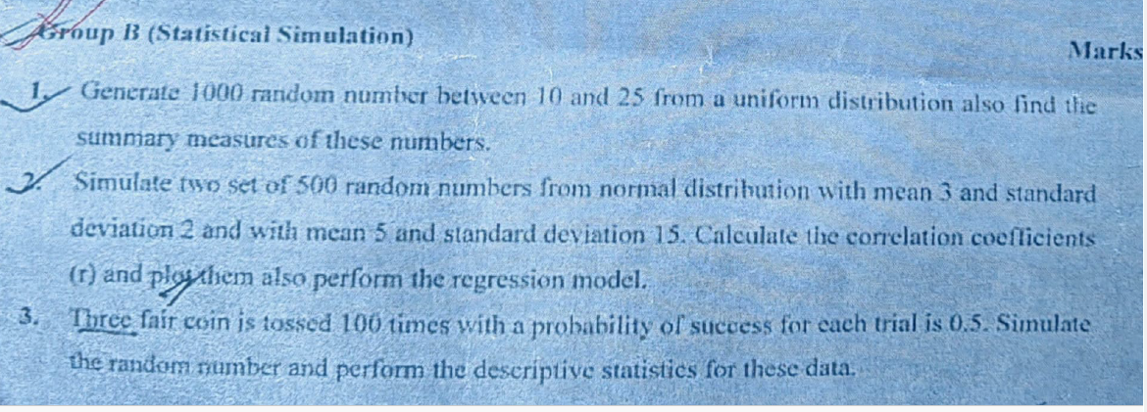

Solve 1:
Functions:
Xi= 10+(25-10) *RAND ()
(Drack it up to 10)
OUTPUT
Xi | summary | function | statistics
11.15275 | mean | =AVERAGE() | 16.82309
23.69278 | median | =MEDIAN() | 17.76631
19.27721 | mode | =MODE() | #N/A
19.58198 | max | =MAX() | 23.69278
14.40486 | min | =MIN() | 11.08006
21.85954 | std. dev | =STDEV.S(A2:A11) | 4.543885
17.98676 | variance | =VAR.S(A2:A11) | 20.64689
11.64913 | Range | =MAX-MIN | 12.61273
17.54587
11.08006

3.Solve
A=IF(RAND()<=0.5,1,0)
B=IF(RAND()<=0.5,1,0)
C=IF(RAND()<=0.5,1,0)
OUTPUT

A | B | C | Sum |  | summary statistics
0 | 0 | 0 | 0 | mean | 1.5
1 | 1 | 1 | 3 | median | 1
1 | 0 | 0 | 1 | mode | 1
1 | 0 | 0 | 1 | max | 3
1 | 1 | 1 | 3 | min | 0
0 | 0 | 1 | 1 | std. dev | 1.178511302
0 | 0 | 0 | 0 | variance | 1.388888889
0 | 1 | 0 | 1 | Range | 3
1 | 0 | 1 | 2
1 | 1 | 1 | 3

